UNIVERSITY LIBRARY

CSC 540 PROJECT REPORT

(**GROUP: 21**. Ashutosh Chaturvedi ● Ayush Gupta ● Jordy Jose ● Priysha Pradhan ● Srishti Arora)

**Table of Contents**

**1. Problem Statement**

**2. Entities and Relationships**

2.1 Entities

2.2 Relationships

**3. Users**

3.1 Student

3.2 Faculty

**4. E-R diagram**

**5. Relational Schemas**

**6. Functional Dependencies and Normal Forms**

**7. SQL queries**

**1. Problem Statement:**

University Library is desktop application to assist with the administration of the library. The application allows library patrons to use the resources available in the two libraries present on campus the D.H Hill Library and the J.B. Hunt Library. Each of the libraries contains certain books, journals, E books, some study/conference rooms and devices like cameras.

**2. Entities and Relationships:**

**2.1 Entities:**

1. Users

This entity has user id and password. This table contains user id for all faculties and students who have activated their account.

1. Students

The entity has student number, first name, last name, home phone, work phone, date of birth, sex, nationality, department id, street, city, pin code, student classification, degree program and student program.

1. Faculty

The entity has faculty number, first name, last name, category, nationality and department id.

1. Courses

The entity has course id, course name and faculty no.

1. Departments

The entity has the department id and name.

1. Addresses

The entity has street, city and pin code.

1. Libraries

The entity contains library id and library name.

1. Ecopy Books

The entity has ISBN, edition, publisher, author, tittle, and year.

1. Ecopy Journals

The entity has ISBN, author, tittle and year.

1. Ecopy Conference

The entity has conference number, conference name, author, year and tittle.

1. Hardcopy Books

The entity has ISBN, edition, publisher, author, tittle, number of copies and year.

1. Hardcopy Journals

The entity has ISBN, author, number of copies, tittle and year.

1. Hardcopy Conference

The entity has conference number, conference name, author, number of, year and tittle.

1. Study-Rooms

The entity contains room number, floor, capacity, library id.

1. Conference-Rooms

The entity contains room number, floor, capacity, library id.

1. Cameras

The entity has camera id, make, model, memory, configuration, library id, is available.

1. Master Messages

The entity has master message id, master message subject, master message text. This table contains static messages.

1. Dues

The relationship contains user id, amount, resource id, due date, paid date, user name.

**2.2 Relationships:**

1. Reserves

This relationship captures faculty and course. It has faculty number, course id, ISBN, expiry date and start date.

1. Enrollment

The relationship has course id and student number and captures relation between courses and student.

1. Book Waitlist

The relationship has user id, book id, date waitlisted and is faculty and it captures relation between user and book.

1. Camera Request

The relationship has user id, start id, end date, check out time, check out end time, check in date time and it captures relation between user and cameras.

1. Camera Wait Queue

The relationship has user id, date waitlist and expected reservation date.

1. Checks Out Ecopy Book

The relationship has user id, ISBN, checks out date and time and return date and time it captures relation between user and book.

1. Checks Out Ecopy Conference

The relationship has user id, conference number, checks out date and time and return date and time. It captures relation between user and conference proceedings.

1. Checks Out Ecopy Journal

The relationship has user id, ISSN, checks out date and time and return date and time. It captures relation between user and journals.

1. Conference Room Reservation

The relationship contains user id, room number, library id, start date, end date, check out deadline, check out date and time and is void. It captures relation between faculty and conference room.

1. Hold User

The relationship contains hold id, user id and hold date. This table contain users whose account got terminated because of dues.

1. Patron Message Notifications

The relationship contains patron message number, patron id, master message id, message generated time and read flag. This table is queried to receive notifications specific to the user.

1. Study Room Reservation

The relationship contains user id, room number, library id, start date, end date, check out deadline, check out date time and check in date time. It captures relation between user and conference room.

**3. Users:**

**3.1 Student:**

Student can request and checkout resources such as reserved books, other books, electronic publications, journals and conference proceedings, study rooms and cameras from the library.

**3.2 Faculty:**

Faculty can request and checkout resources such as books, electronic publications, journals and conference proceedings, study rooms, conference rooms and cameras from the library. Faculty can also reserve a book for a course.

**4. E-R Diagram:**

1. Library Patrons:

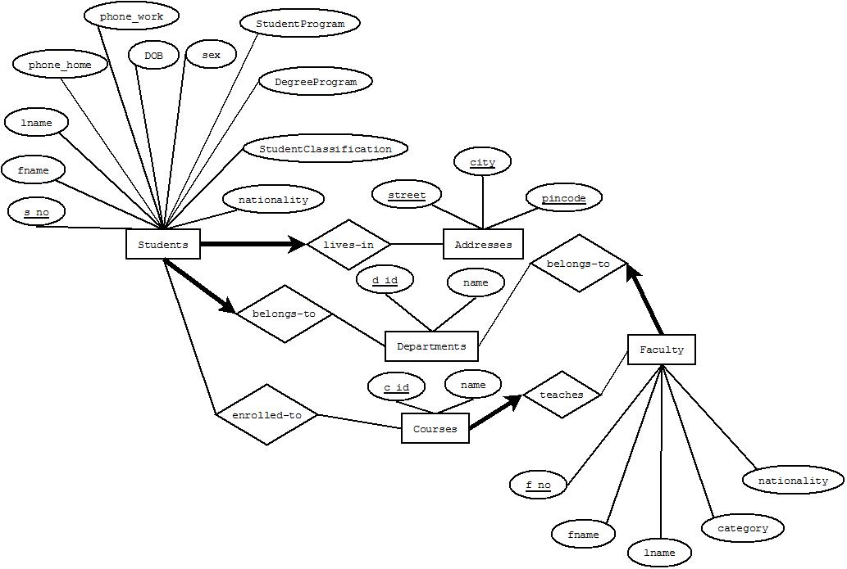

1. Publications:

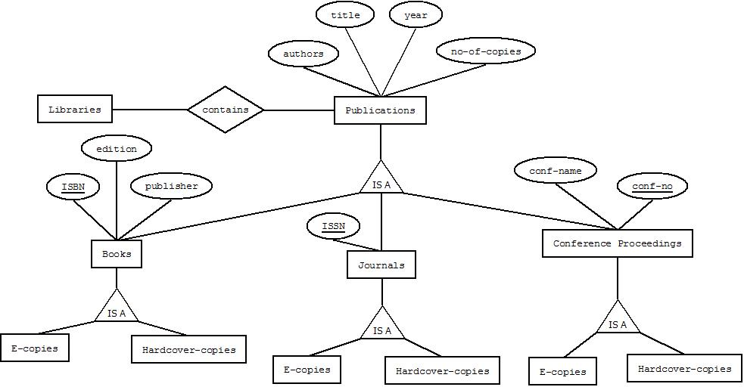

1. Books Checkout:

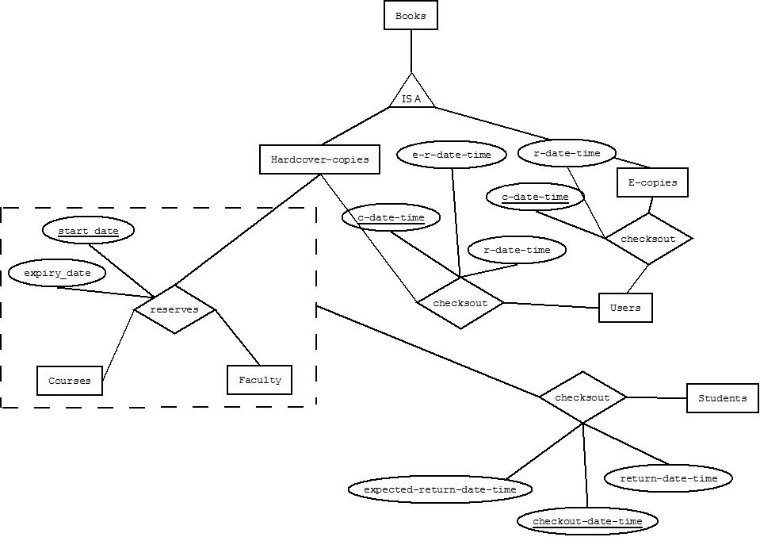

1. Journals Checkout:

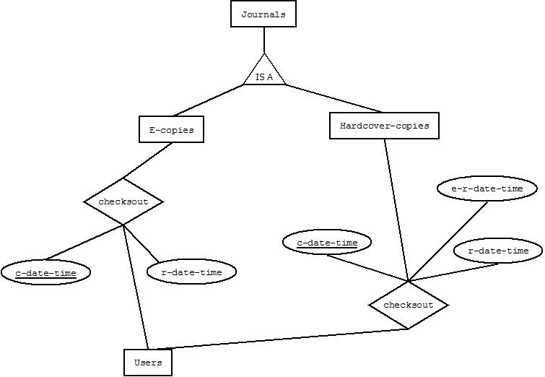

1. Study Rooms:

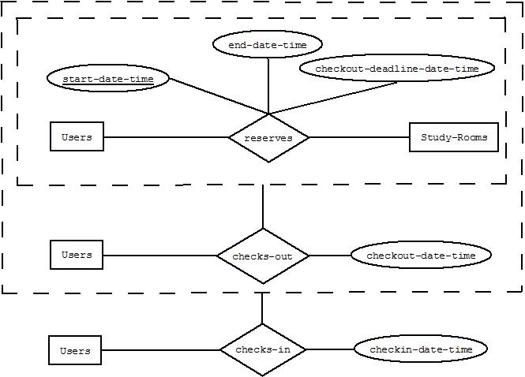

1. Conference Proceedings Checkout:

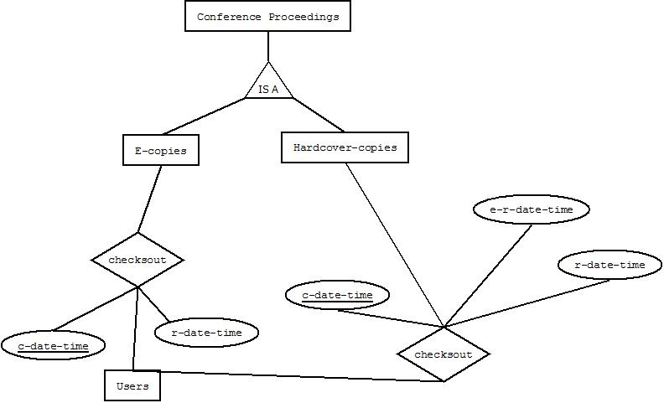

1. Study Room Reservation:



1. Faculty Room Reservation:

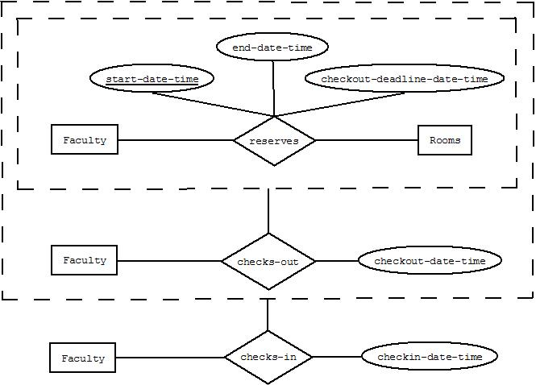

1. Student Camera Reservation:

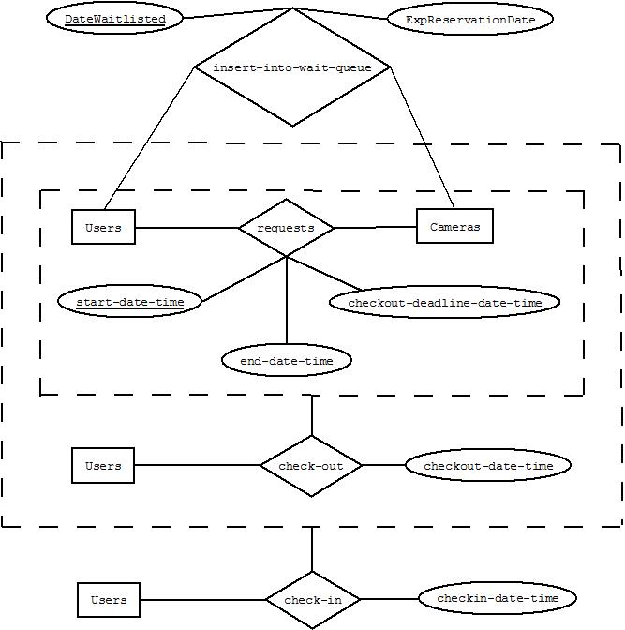

1. Camera Reservation:

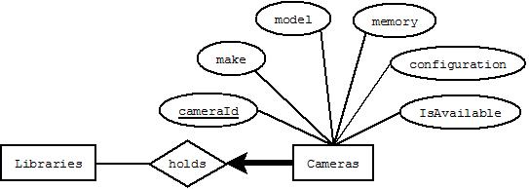

1. Waitlist:

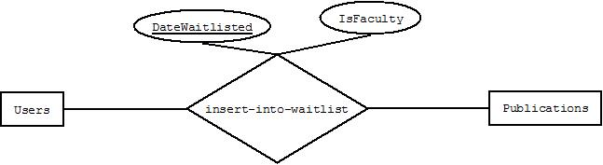

1. Faculty Camera Reservation:

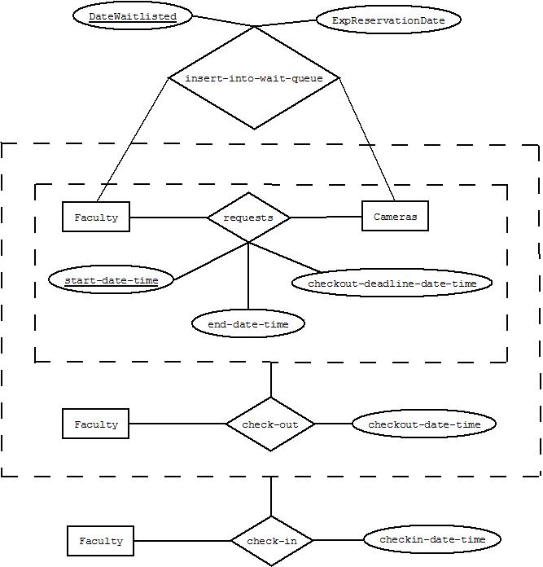

**6. Relationship Schema:**

1. Faculty (*facultyNo:* **integer**, *firstName:* **varchar**, *lastName:* **varchar**, *category:* **varchar**, *nationality:* **integer**, *deptId:* **varchar**)

*deptId* REFERENCES Departments(*deptId*)

1. Students (*studentNo:* **intxeger**, *firstName:* **varchar**, *lastName:* **varchar**, *homePhone:* **integer**, *workPhone:* **integer**, *dob:* **datetime**, *sex:* **varchar**, *nationality:* **varchar**, *deptId:* **varchar,** *street:* **varchar**, *city:* **varchar**, *pincode:* **varchar**)

*deptId* REFERENCES Departments(*deptId*)

*street* REFERENCES Addresses(*street*)

*city* REFERENCES Addresses(*city*)

*pincode* REFERENCES Addresses(*pincode*)

1. Addresses (*street:* **varchar**, *city:* **varchar**, *pincode:* **varchar**)
2. Departments (*deptId:* **varchar**, *name:* **varchar**)
3. Libraries (*libraryId:* **integer**, *name:* **varchar**)
4. Courses (*courseId:* **varchar**, *courseName:* **varchar**, *name:* **varchar**, *facultyNo:* **integer**)

*facultyNo* REFERENCES Faculty (*facultyNo*)

1. EcopyBooks (*ISBN:* **integer***, edition:* **varchar***, publisher:* **varchar***, author:* **varchar***, title:* **varchar***, noOfCopies:* **integer***, year:* **integer**)
2. HardcopyBooks (*ISBN:* **integer***, edition:* **varchar***, publisher:* **varchar***, author:* **varchar***, title:* **varchar***, noOfCopies:* **integer***, year:* **integer**)
3. EcopyJournals (*ISSN:* **integer***,  author:* **varchar***, title:* **varchar***, noOfCopies:* **integer***, year:* **integer)**
4. HardcopyJournals (*ISSN:* **integer***,  author:* **varchar***, title:* **varchar***, noOfCopies:* **integer***, year:* **integer)**
5. EcopyConf (*confNo:* **integer***, confName:* **varchar***, author:* **varchar***, title:* **varchar***, noOfCopies:* **integer***, year:* **integer**)
6. HardcopyConf (*confNo:* **integer***, confName:* **varchar***, author:* **varchar***, title:* **varchar***, noOfCopies:* **integer***, year:* **integer**)
7. Camera (*cameraId:* **integer**, *make:* **varchar**, *model:* **varchar**, *memory:* **varchar**, *configuration:* **varchar**, *isAvailable:* **varchar**, *libraryId:* **integer**)

*libraryId* REFERENCES Libraries (*libraryId*)

1. StudyRooms (*roomNo:* **varchar**, *floor:* **integer**, *capacity:* **integer**, *libraryId:* **integer**)

*libraryId* REFERENCES Libraries (*libraryId*)

1. StudyRoomsReservation (userId: **varchar***, roomNo:* **varchar**, *libraryId:* **integer,** *startDate:* **date,** *endDate:* **date**)

*roomNo, libraryId* REFERENCES StudyRooms (*roomNo, libraryId*)

*userId* REFERENCES User (*userId*)

1. ConferenceRooms (*roomNo:* **varchar**, *floor:* **integer**, *capacity:* **integer**, *libraryId:* **integer**)

*libraryId* REFERENCES Libraries (*libraryId*)

1. Duration (*startDate:* **datetime**, *endDate:* **datetime**)
2. Reserves (*facultyNo:* **integer**, *courseId:* **integer**, *ISBN:* **integer**, *expiryDate:* **datetime**, *startDate:* **datetime**)

*facultyNo* REFERENCES Faculty(facultyNo)

*courseId* REFERENCES Courses(*courseId)*

*ISBN* REFERENCES HardcopyBooks(*ISBN)*

1. Camera Request (*userId:* **varchar***, cameraId:* **varchar,** *startDate:* **date,** *endDate:* **date,** *:* **date,** *checkoutEndTime***: date,** *checkinDateTime:* **date**)

*cameraId* REFERENCES Cameras(*cameraId*)

*userId* REFERENCES User (*userId*)

1. CameraWaitQueue (*userId:* **varchar***, cameraId:* **varchar,** *dateWaitListed:* **date,** *expReservationDate:* **date**)

*cameraId* REFERENCES Cameras(*cameraId*)

*userId* REFERENCES User (*userId*)

1. ChecksoutEcopyBook (*userId:* **varchar***, ISBN:* **varchar,** *cDateTime:* **date,** *rDateTime:* **date**)

*ISBN* REFERENCES EcopyBooks (*ISBN*)

*userId* REFERENCES User (*userId*)

1. ChecksoutEcopyConf (*userId:* **varchar***, confNo:* **varchar,** *cDateTime:* **date,** *rDateTime:* **date**)

*confNo* REFERENCES EcopyConf (*confNo*)

*userId* REFERENCES User (*userId*)

1. ChecksoutEcopyJournal (*userId:* **varchar***, ISSN:* **varchar,** *cDateTime:* **date,** *rDateTime:* **date**)

*ISSN* REFERENCES HardcopyJournals(*ISSN*)

*userId* REFERENCES User (*userId*)

1. ChecksoutHardcopyBook (*userId:* **varchar***, ISBN:* **varchar,** *cDateTime:* **date,** *rDateTime:* **date,** *erDateTime:* **date**)

*ISBN* REFERENCES HardcopyBooks (*ISBN*)

*userId* REFERENCES User (*userId*)

1. ChecksoutHardcopyConf (*userId:* **varchar***, confNo:* **varchar,** *cDateTime:* **date,** *rDateTime:* **date,** *erDateTime:* **date**)

*confNo* REFERENCES HardcopyConf (*confNo*)

*userId* REFERENCES User (*userId*)

1. ChecksoutHardcopyJournal (*userId:* **varchar***, ISSN:* **varchar,** *cDateTime:* **date,** *rDateTime:* **date,** *erDateTime:* **date**)

*ISSN* REFERENCES HardcopyJournals(*ISSN*)

*userId* REFERENCES User (*userId*)

1. ConferenceRoomReservation (*userId:* **varchar***, roomNo:* **varchar,** *libraryId:* **varchar,** *startDate:* **date,** *endDate:* **date,** *checkoutDeadline:* **date,** *checkoutDateTime:* **date,** *checkinDateTime:* **date,** *isVoid:* **varchar**)

*roomNo, libraryId* REFERENCES StudyRooms (*roomNo, libraryId*)

*userId* REFERENCES User (*userId*)

1. Enrollment (*courseId:* **varchar**, *studentNo:* **integer**)

*courseId* REFERENCES Courses (*courseId*)

1. BookWaitlist (*userId:* **varchar**, *bookId:* **varchar,** *dateWaitlisted:* **date,** *isFaculty:* **char**)

*userId* REFERENCES User (*userId*)

1. Dues (*userId:* **varchar***, resourceId:* **varchar,** *Amount:* **integer,** *dueDate:* **date,** *paidDate:* **date, ,** *isPaid:* **char**)
2. HoldUser (*userId:* **varchar***, holdId:* **integer,** *holdDate:* **date**)

*userId* REFERENCES User (*userId*)

1. MasterMessages (*masterMessageId:* **varchar***, masterMessageSubject:* **varchar,** *masterMessageText:* **varchar**)
2. PatronMessageNotifications (patronMessageNo: **integer,** *patronId:* **varchar***, masterMessageId:* **varchar,** *readFlag:* **varchar**)

*masterMessageId* REFERENCES MasterMessages (*masterMessageId*)

**7. Functional Dependencies:**

|  |  |
| --- | --- |
| RELATION | FUNCTIONAL DEPENDENCY |
| STUDENTS | studentNo, deptId, street, city, pincode -> firstName, lastName, homePhone, workPhone, dob, sex, nationality |
| COURSES | courseId, facultyNo -> name |
| FACULTY | facultyNo, deptId -> fisrtName, lastName, category, nationality |
| DEPARTMENTS | deptId -> name |
| CONFERENCE PROCEEDINGS | confNo -> confName |
| ECOPYBOOKS | ISBN -> edition, publisher, author, title, noOfCopies, year |
| HARDCOPYBOOKS | ISBN -> edition, publisher, author, title, noOfCopies, year |
| ECOPYJOURNALS | ISSN -> edition, publisher, author, title, noOfCopies, year |
| HARDCOPYJOURNALS | ISSN -> edition, publisher, author, title, noOfCopies, year |
| ECOPYCONF | confNo -> confName, author, title, noOfCopies, year |
| HARDCOPYCONF | confNo -> confName, author, title, noOfCopies, year |
| STUDYROOMS | roomNo, libraryId -> floor, capacity |
| STUDYROOMSRESERVATION | roomNo, libraryId, userId, startDate -> endDate |
| CONFERENCE ROOMS | roomNo, libraryId -> floor, capacity |
| LIBRARIES | Id -> name |
| BOOKWAITLIST | facultyId, dateWailisted, userId -> isFaculty |
| CAMERA | cameraId, libraryId -> make, model, memory, configuration, isAvailable, |
| CAMERAREQUESTS | userId, cameraId, startdate -> userId, cameraId , endDate, checkoutEndTime, checkinDateTime |
| CAMERAWAITQUEUE | userId, cameraId, daitWaitlisted -> expReservationDate |
| STUDYROOMRESERVATION | userId, |
| LIBRARIES | LibraryId - > name |
| RESERVES | facultyNo , courseId, ISBN -> expiryDate, startDate |
| CHECKSOUTECOPYBOOK | userId, ISBN, cDateTime -> rDateTime |
| CHECKSOUTECOPYCONF | userId, confNo, cDateTime -> rDateTime |
| CHECKSOUTECOPYJOURNAL | userId, ISSN, cDateTime -> rDateTime |
| CHECKSOUTHARDCOPYBOOK | userId, ISBN, cDateTime -> rDateTime, erDateTime |
| CHECKSOUTHARDCOPYCONF | userId, confNo, cDateTime -> rDateTime, erDateTime |
| CHECKSOUTHARDCOPYJOURNAL | userId, ISSN, cDateTime -> rDateTime, erDateTime |
| CONFERENCEROOMRESERVATION | userId, roomNo, startDate -> libraryId, endDate, checkoutDeadline, checkoutDateTime, checkinDateTime, isVoid |
| DUES | userId, resourceId, dueDate -> Amount paidDate, isPaid |
| BOOKWAITLIST | userId, dateWaitlisted -> bookId, isFaculty |
| HOLDUSER | UserId -> holdId, holdDate |
| MASTERMESSAGES | MasterMessageId -> masterMessageSubject, masterMessageText |
| PATRONMESSAGENOTIFICATIONS | patronMessageNo, MasterMessageId -> patronId, readFlag |
|  |  |

All the FD of all the relation are either trivial or the attributes on left side is the primary keys of the relation. So we can conclude that all the relations are in BCNF.

**8. Constraints:**

There are few constraints which were implemented in Java rather than in the DBMS. They are as following:

1. A camera can be reserved only on a Friday.

A patron can reserve cameras. However the reservations are allowed only on Fridays. One reason not to implement this constraint in the DBMS was, this is not a very intuitive use case and the user of the application would like to receive a notification immediately if he/ she attempts to reserve a camera on a day other than Friday. Implementing the constraint in the DBMS means the java code will have to catch the right exception, interpret it and show the right error message.

**9. SQL Queries:**

1. **List in descending order the names of the patrons and the number of times they failed to return a resource on time from Oct 5th to Nov 5th, 2015.**

select d.user_id, s.firstname name, count(d.user_id) count

from dues d, students s

where d.user_id=s.studentno and d.duedate between TO_DATE('2015/10/05', 'YYYY/MM/DD') AND TO_DATE('2015/11/05', 'YYYY/MM/DD')

group by d.user_id, s.firstname

UNION

select d.user_id, f.firstname, count(d.user_id)

from dues d, faculty f

where d.user_id=f.facultyno and d.duedate between TO_DATE('2015/10/05', 'YYYY/MM/DD') AND TO_DATE('2015/11/05', 'YYYY/MM/DD')

group by d.user_id, f.firstname

order by count desc;

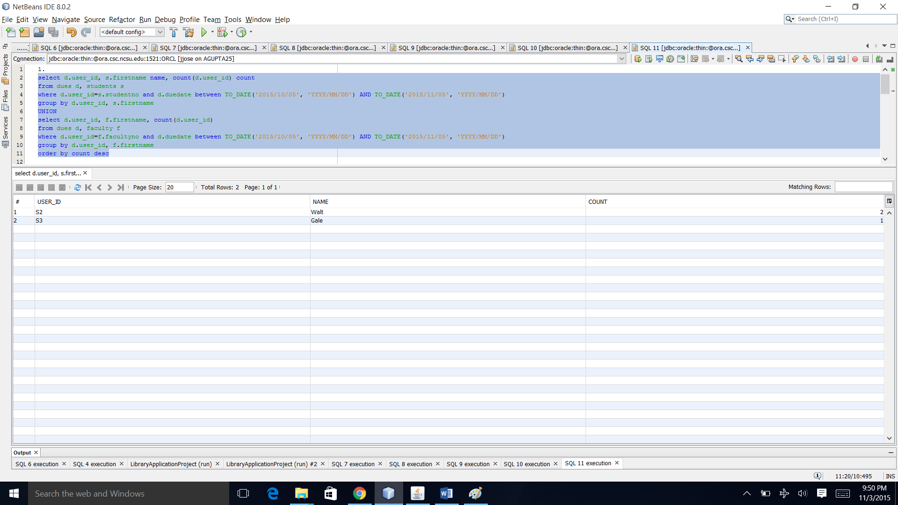

1. **List the number of room reservations from Oct 30th to Nov 6th, 2015 that were rendered null and void because the patron failed to check in within the first one hour.**

select SUM(rooms) TotalVoidRooms

FROM

(

select count(*) rooms from studyroomreservation

where isvoid = 'Y' and startdate between TO_DATE('2015/10/30', 'YYYY/MM/DD') AND TO_DATE('2015/11/06', 'YYYY/MM/DD')

UNION ALL

select count(*) rooms from conferenceroomreservation

where isvoid = 'Y' and startdate between TO_DATE('2015/10/30', 'YYYY/MM/DD') AND TO_DATE('2015/11/06', 'YYYY/MM/DD')

);

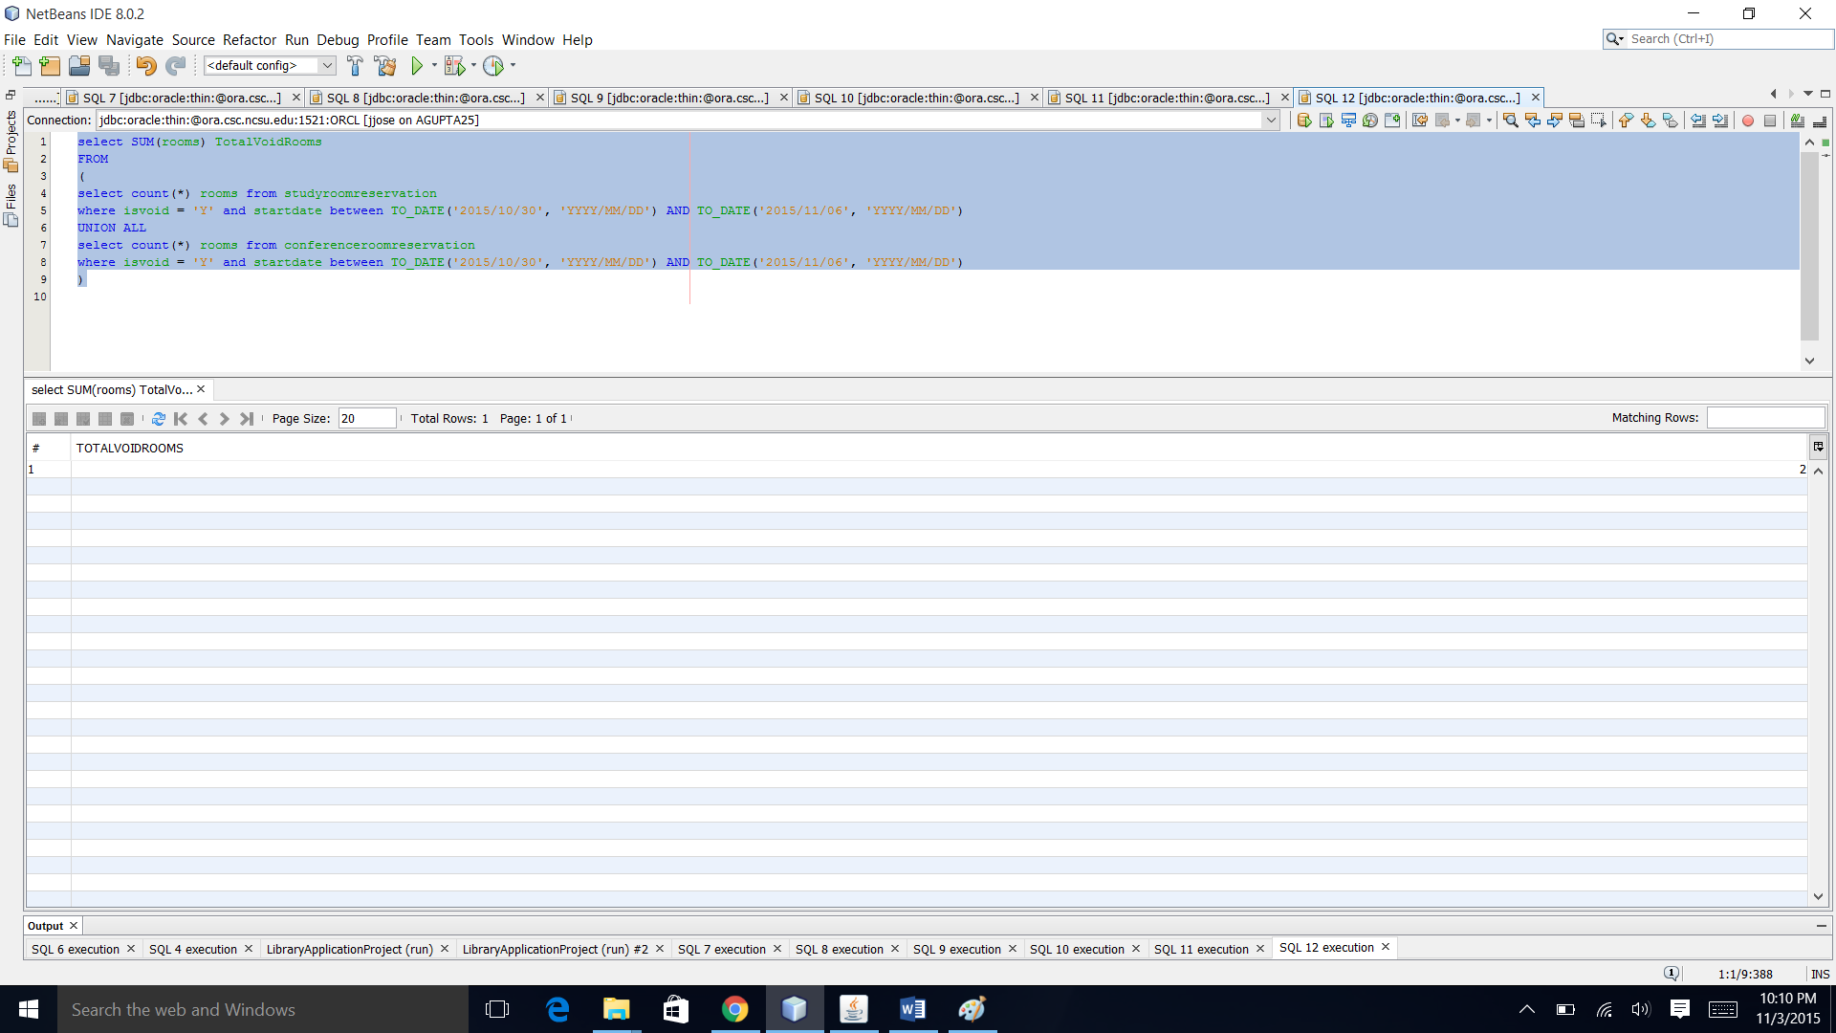

1. **What is the total amount of money that the library received between Oct 5th to Nov 5th, 2015 in terms of late fees for all resources from all patrons.**

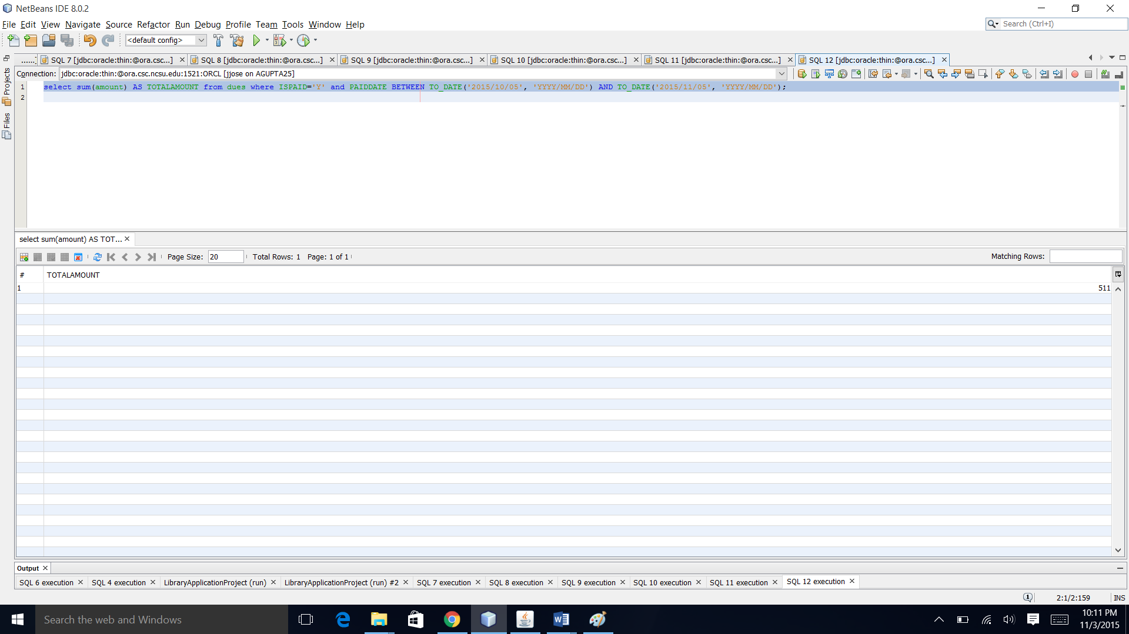select sum(amount) AS TOTALAMOUNT from dues where ISPAID='Y' and PAIDDATE BETWEEN TO_DATE('2015/10/05', 'YYYY/MM/DD') AND TO_DATE('2015/11/05', 'YYYY/MM/DD');

1. Using the number of requests between Oct 5th to Nov 5th, 2015 as a parameter determine what capacity rooms are in maximum demand.

select max(CAPACITY) CAPACITY_IN_DEMAND FROM

(

Select capacity from

(

SELECT r.roomno, s.capacity , count(r.roomno) cnt

from studyroomreservation r, studyrooms s

where r.roomno = s.roomno and r.startdate between TO_DATE('2015/10/05', 'YYYY/MM/DD') AND TO_DATE('2015/11/05', 'YYYY/MM/DD')

GROUP BY r.roomno, s.capacity

UNION

SELECT r.roomno, s.capacity , count(r.roomno) cnt

from conferenceroomreservation r, conferencerooms s

where r.roomno = s.roomno and r.startdate between TO_DATE('2015/10/05', 'YYYY/MM/DD') AND TO_DATE('2015/11/05', 'YYYY/MM/DD')

GROUP BY r.roomno, s.capacity

)

group by capacity

) ;

